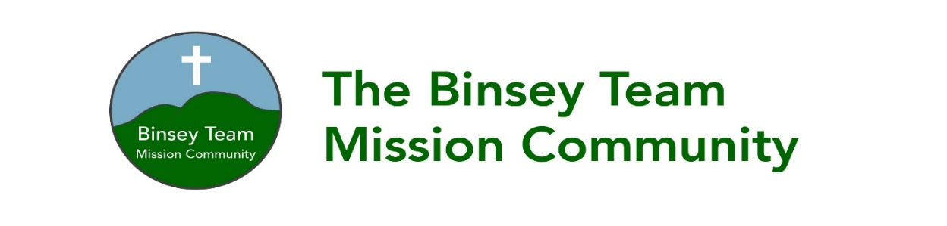
We hope you’ve enjoyed being with us and we would love to stay in touch with you. If you would like to be informed of future events and other church news please tick the boxes below and let us have your contact details. (please tick the boxes where you grant consent):-
Name ________________________________________________________________________
Address ______________________________________________________________________
_____________________________________________________________________________
Email Address: _________________________________________________________________
Phone Number:: ________________________________________________________________
Signed: ________________________________________ Dated: _____________________
☐ To keep me informed about news, events, activities and services in The Binsey Team Mission Community
I consent to the church contacting me by post phone or email or SMS text msg.
You can unsubscribe at any time by contacting the Binsey Team Administrator admin@binsey.org.uk 01900 828651 or 07742354499
The Binsey Team Ministry PCC is a charity registered in England and Wales (No 1169267)

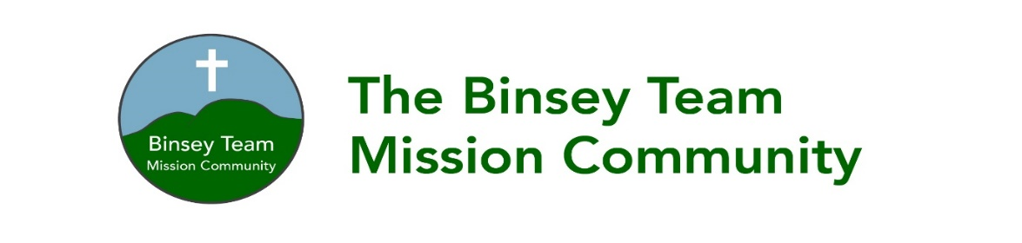
We hope you’ve enjoyed being with us and we would love to stay in touch with you. If you would like to be informed of future events and other church news please tick the boxes below and let us have your contact details. (please tick the boxes where you grant consent):-
Name __________________________________________________________________________
Address ________________________________________________________________________
_______________________________________________________________________________
Email Address: ___________________________________________________________________
Phone Number:: ___________________________________________________________________
Signed: ___________________________________________ Dated: _____________________
☐ To keep me informed about news, events, activities and services in The Binsey Team Mission Community
I consent to the church contacting me by post phone or email or SMS text message
You can unsubscribe at any time, either by contacting the Binsey Team Administrator admin@binsey.org.uk 01900 828651 or 07742354499
The Binsey Team Ministry PCC is a charity registered in England and Wales (No 1169267)

